TrashHeap App: Screen Shots

Somerset College Year 9 Tech Girls

App screens | Features & functionality
Opening ‘splash’ screen logo
This screen was developed last and due to a limitation (bug) found in MIT App Inventor the team could not force the application to start with this screen because it was not the 1st screen that had been developed.

This is now the screen that the user is moved to first when they click on the Exit button on the Home screen. Code was included to delay the closing of the application so that this logo would be shown but MIT App Inventor is very ‘buggy’ and seems to get stuck sequencing this code.

Future upgrades of this app would include updating the app to ensure this is the first screen that the user sees.
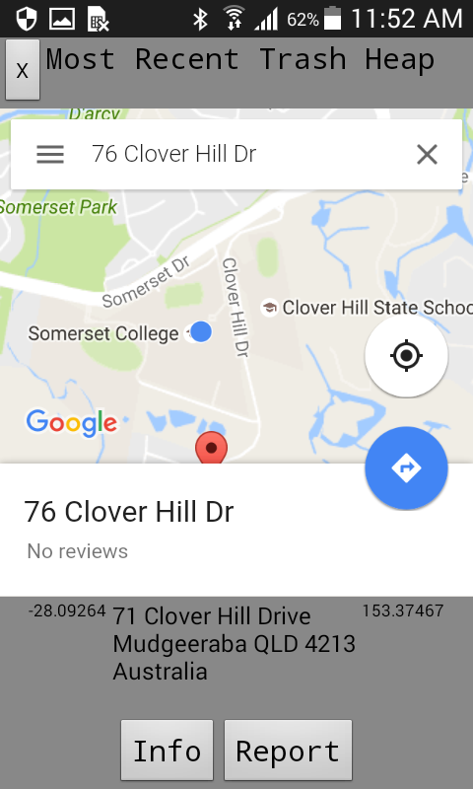 | Home Screen  The team wanted to show the most recent trap heap submitted to the web database showing on the Main screen. This proved to be too difficult for the team at this time, so it now shows your current location on the map.  The Info button gives information to the user about the issue of trash in our community.  The Report button allows the user to report a trash heap location by adding the address to the database.
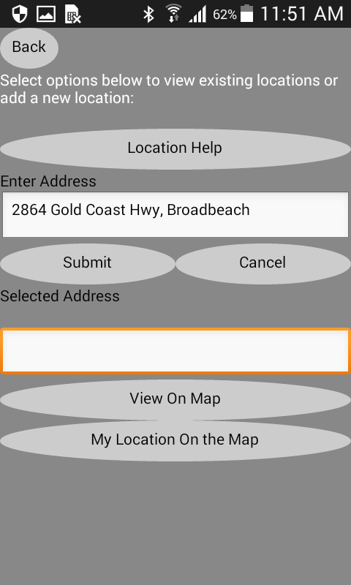 | Report Screen  The Report screen allows the user to choose ‘Location Help’ to get brief instructions on how to use this screen.  When the user sees a location with a lot of trash, they would open this screen and type the address in the first textbox. Alternatively, the user can find their location by clicking on the ‘My Location on the Map’ link. Clicking the Submit button enters the location of the Trash Heap.  You can also view a selected address location on the map.
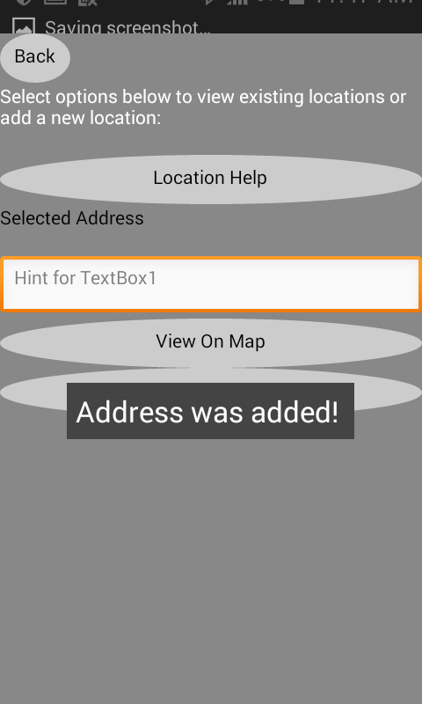 | Successfully adding an address of a Trash Heap to the database.
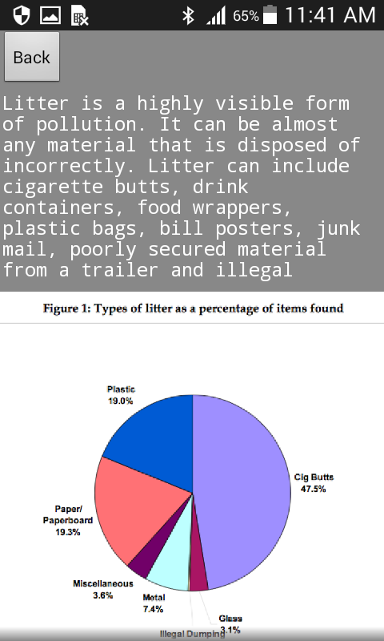 | Info Screen  This screen includes information about the issue of trash and pollution in our community. The purpose of this screen is to build awareness about the environment.

