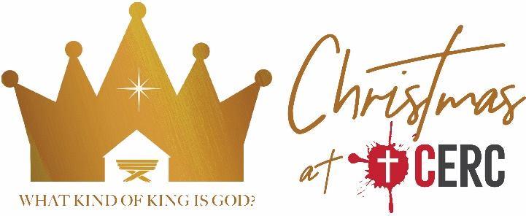

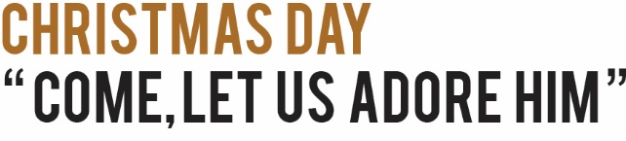
Matthew 2:1-12 (CSB) | 25 December 2019

^{2:1} After Jesus was born in Bethlehem of Judea in the days of King Herod, wise men from the east arrived in Jerusalem, ² saying, “Where is he who has been born king of the Jews? For we saw his star at its rising and have come to worship him.” ³ When King Herod heard this, he was deeply disturbed, and all Jerusalem with him. ⁴ So he assembled all the chief priests and scribes of the people and asked them where the Christ would be born. ⁵ “In Bethlehem of Judea,” they told him, “because this is what was written by the prophet:
⁶ “And you, Bethlehem, in the land of Judah,
are by no means least among the rulers of Judah:
Because out of you will come a ruler
who will shepherd my people Israel.””
⁷ Then Herod secretly summoned the wise men and asked them the exact time the star appeared. ⁸ He sent them to Bethlehem and said, “Go and search carefully for the child. When you find him, report back to me so that I too can go and worship him.”
⁹ After hearing the king, they went on their way. And there it was—the star they had seen at its rising. It led them until it came and stopped above the place where the child was. ¹⁰ When they saw the star, they were overwhelmed with joy. ¹¹ Entering the house, they saw the child with Mary his mother, and falling to their knees, they worshiped him. Then they opened their treasures and presented him with gifts: gold, frankincense, and myrrh. ¹² And being warned in a dream not to go back to Herod, they returned to their own country by another route.

Christmas is about a king called “the Christ”

Our world has lots of bad kings

The Christ will come from Bethlehem

The Christ: A king worthy to be worshipped by all people

He leads God’s people like a good shepherd

Jesus is the Christ who is worthy of our worship

We fail to worship Jesus

Jesus was crucified to save sinners

