"Can we provide for our Do..."
Yahoo/COVID-19

Vinita Agrawal <support@localcirclesmail.com>
To:gcmbinty@yahoo.com
Mon, Apr 6 at 1:09 PM, 2020.
Vinita Agrawal | Vinita Agrawal shared a new photo in "India Against Coronavirus ".  Subject: Can we provide for our Doctors.  The attached letter is sad. Escalating it here so the govt officials and citizens can both see and do something.  If we cant care for docs how will they care for us?  View Attachment(s)/Reply Reply to this email to post a comment.
If you believe that this post is inappropriate for this Circle, report it.
If you don't want to receive emails from us in future, please Unsubscribe.
Vinita Agrawal
Can we provide for our Doctors
The attached letter is sad. Escalating it here so the govt officials and citizens can both see and do something.
If we cant care for docs how will they care for us?
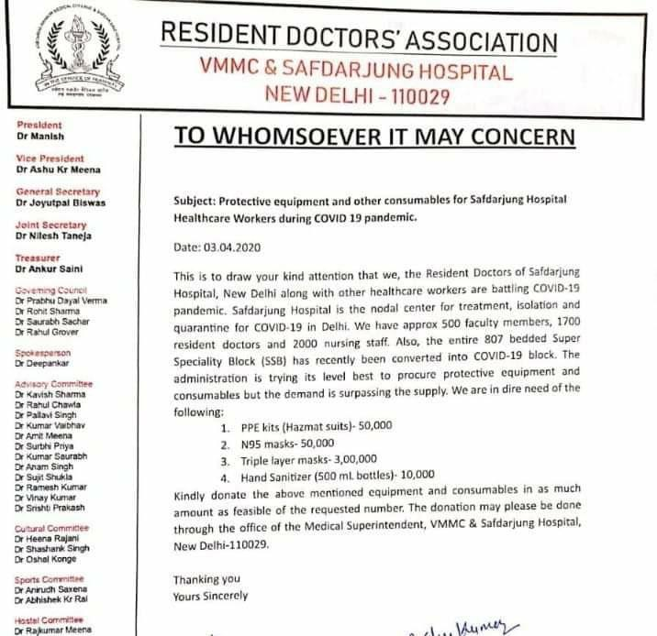
Helpful India Against CoronavirusYesterdayWhatsapp
1 other(s) found it helpfulViewed by 304

RAJARSHI DAS
It's the steady availability of PPE and not money that's essential right now. Should be procured thru govt (controlled prices)..
We probably require more of disposable Hazmat suits..I presume some existing and new enterprises are manufacturing them..will be utterly difficult to get the imported ones though..
Hope we won't have to resort to use of single use plastics in case of lack of Hazmat suits.. like what's happening in Europe..
2 hour(s) ago | Reply |

Kiran Dambalkar (Health Care manager)
Yes very apt indeed..
Yesterday | Reply |

G. C. Mathur (Consumer Activist)
It is consumers' way of participating in the fight against COVID-19 virus that our doctors and nurses facing at the 'front'.
Yesterday | Reply |
G. C. Mathur (Consumer Activist)
Yes, we the citizens (consumers) must do something.
My suggestion here is that the Members of the Consumer Protection Councils at the Centre and the States may jointly pass a resolution to sanction a sum of Rs.5,00,00,000/- (INR 5 crores only) from Senior Citizens Welfare Fund, transferred illegally from the personal money of consumers lying unclaimed and unrefunded in the Finance Act of 2015 (Chapter VII), be passed for specific purpose of purchasing protective equipment and other consumables. This money may be equitably distributed by the Central Consumer Protection Council.
I personally request the Secretary, GoI, DoCA, here to call a meeting of the CCPC and get the Resolution passed accordingly. Thanks
Yesterday | Reply |

Prithvi Nath Bhargava
Is there no politics in this time of crises? No common man can help in the matter.
Yesterday | Reply |

Naganand Nileshwar
COVID-19__Lighting_Candles_Risking_Grid_Collapse_in_India_Under_Lockdown20200406022608
Please do not try to encash by politicising the issue of Corona Virus. One more apprehension was similarly evoked. Nothing happened.
Yesterday | Reply |

Varun Prakash Sharma
I am wondering why this letter is addressed to "whomsoever it may concern". Does the doctor members of the association not know who should be approached for the requirements... more
1 other(s) found it helpfulYesterday | Reply |

Sanjeev Kumar
I posted in my media group friends to bring it to their notice if not already.
Yesterday | Reply |

Prithvi Nath Bhargava
I believe Govt. is aware of the problem and taking appropriate action.
Yesterday | Reply |

Anil Chandhok
Please send this to Dr. Harsh Vardhan and the Ministry of Health & Family Welfare with cc to NITI Ayog. They will take immediate, feasible action.
1 other(s) found it helpfulYesterday | Reply |

…………………………………….

