海洋公園 Chill 級保育日2021
Ocean Park Conservation Chill Club Day 2021
《小紅熊校園生態遊》繪畫比賽參加表格
“Redd’s Ecotour to Schools” Drawing Ccompetition Application Form
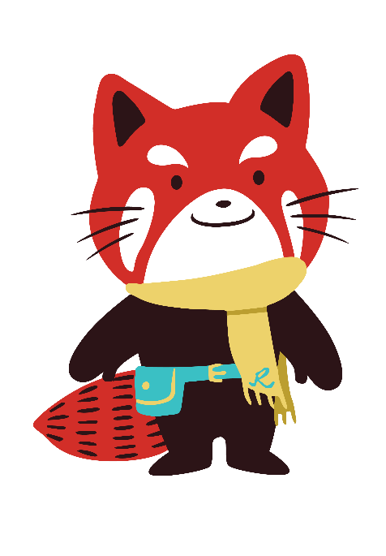
（小學、中學適用 For Participating Primary & Secondary Schools）

姓名  Name: |  | 班別  Class:
學校
School:
請將此表格上載至https://oceanparkhongkong.ievent.hk/event/conservation-chill-club-day
Please upload the drawing to https://oceanparkhongkong.ievent.hk/event/conservation-chill-club-day.

截止日期: 2021年7月16日下午5時 Deadline: 16 July 2021, 5pm

