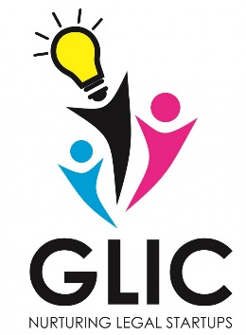
Student Startups & Innovation Policy
Govt. of Gujarat

GNLU LEGAL INCUBATION COUNCIL
in association with
STUDENT STARTUPS & INNOVATION POLICY, GOVERNMENT OF GUJARAT
organizes
National Film Making Competition on Entrepreneurship & Startups - 2018

Registration Form

About the Film
Title in Original Language | :
Title in English | :
Key Words | :
Duration of Film (Min, Sec) | :
Geographical Area of Film  City, State, Country | :
YouTube Link of Film

Name of YouTube Link  (In English) |  | Name of Film|Name of Person or Group|GLIC-GNLU 2018  In Description  Submitted to National Film Making Competition on Entrepreneurship & Startups - 2018  Brief Description about film i.e. Synopsis
Synopsis (100 Words) | :
About Direction
Name of Director | :
Contact Address | :
Email | :
Mobile No. | :
Organization/Institutions | :
Production
Producer Name | :
Contact Address | :
Email | :
Mobile No. | :
Approximate Budget of Film | :

Declaration :-

I/We hereby declare that I/We have not submitted present film for any competition. I/We hereby attest that details given above are accurate and correct. I/We shall adhere to the guidelines of the competition. I/We will abide by the decision of the organizer.

Place :- | Signature :- Put Image of Signature
Date :- | Name :-

Note :- Send soft copy of registration form in PDF to glic@gnlu.ac.in alongwith YouTube link of the film.

