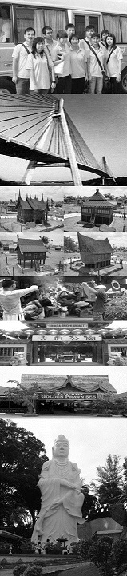
update: 030118
GV2  WATERVILLAS | ADULT |  |  |  | CHILD
 | Single | Twin | Third  Person | Fourth  Person | With Bed | No Bed | Infant
2D/1N Tour Package | S$185 | S$105 | S$85 | S$54 | S$70 | S$39 | S$15
2D/1N Free & Easy | S$175 | S$95 | S$75 | S$44 | S$62 | S$35 | S$15
Extension Night | S$160 | S$80 | S$60 | S$38 | S$50 | S$11 | FOC
Per person per night
Tour Package Include of :
Return Ferry Ticket (Sin/Bth/Sin) by Sindo Ferry Pte Ltd, 1 Night Hotel Accommodation with Breakfast, 1 Day Batam City & Shopping Tour with Seafood Lunch & Land Transfer and Local Guide Assist.
Free & Easy Package Include of :
Return Ferry Ticket (Sin/Bth/Sin) by Sindo Ferry Pte Ltd, 1 Night Hotel Accommodation with Breakfast, Land Transfer (pier/hotel/pier) and Local Guide Assist.
Extension Night Include of :
1 Night Hotel Accommodation with Breakfast.

The Package Exclude of:
- Singapore PDF & Fuel Surcharge of S$21/pax (subject to change)
- Batam Terminal Fee of S$8/pax (subject to change)
- Batam Guide & Driver Tipping of S$2/pax/day.
SBS RESORT BARELANG
- Personal Insurance, Room Service, Optional Tours, Porterage Fee, Visa Fee, and all expenses of personal nature

Upgrading Room Surcharge:
- No Room Upgrading

Eve, PH & School Holiday Surcharge:
- No Public Holiday & Peak Season Surcharge apply.

Fixed Departure:
All above package is based on FIXED DEPARTURE BASIC as following:
- By Tour Package is 0900 hrs.
- By Free & Easy is 0900, 1020, 1320, 1450 & 1720 hrs.
- Pick-up from hotel to Ferry Terminal is all fixed at 1200 hrs.
- Require for early or late departure will be imposed additional surcharge for land transfer is S$10/pax/trip for 8am to 6pm and S$15/pax/trip for 6pm to 9pm and midnight charge for after 9pm is S$25/pax/trip (min must 02 paxs)

Remark:
- Validity from 1 APRIL till 30 DECEMBER 2018.
- Hotel room’s definition for Weekday is Sunday to Thursday and Weekend is Friday to Saturday and eve of & PH.
- No cancellation & no amendment is allowed after reservation made. 100% full fare charge applies.
- Itinerary is subject to change without prior notice
- All prices herein are subject to change without prior notice, arising from currency fluctuation, local taxes, etc.
- All prices herein quoted are subject to based on City and Shopping Tour Itinerary (GV2), upgrading to Historical and Shopping Tour (GV6) or Muslim Tour (GV4) TOP-UP S$10/pax

