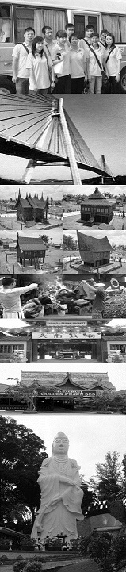
update 111217
GV2 | ADULT |  | CHILD
SUPERIOR ROOM | Single | Dbl/Trp | Half Twin | With Bed | No Bed | Infant
2D/1N Tour Package | S$139 | S$82 | S$78 | S$78 | S$39 | S$15
2D/1N Free & Easy | S$130 | S$72 | S$70 | S$70 | S$35 | S$15
Extension Night | S$112 | S$56 | S$56 | S$56 | S$11 | FOC
Per person per night
Tour Package Include of :
Return Ferry Ticket (Sin/Bth/Sin) by Sindo Ferry Pte Ltd, 1 Night Hotel Accommodation with Breakfast, 1 Day Batam City & Shopping Tour with Seafood Lunch & Land Transfer and Local Guide Assist.
Free & Easy Package Include of :
Return Ferry Ticket (Sin/Bth/Sin) by Sindo Ferry Pte Ltd, 1 Night Hotel Accommodation with Breakfast, Land Transfer (pier/hotel/pier) and Local Guide Assist.
Extension Night Include of :
1 Night Hotel Accommodation with Breakfast.

The Package Exclude of:
- Singapore PDF & Fuel Surcharge of S$21/pax (subject to change)
- Batam Terminal Fee of S$8/pax (subject to change)
- Batam Guide & Driver Tipping of S$2/pax/day.
- Personal Insurance, Room Service, Optional Tours, Porterage Fee, Visa Fee, and all expenses of personal nature
Grand iHotel Nagoya

Upgrading Room Surcharge:
- Upgrading to Balcony Room top-up S$20/r/n, Deluxe Room top-up S$25/r/n, Suite Room top-up S$270/r/n

Eve, PH & School Holiday Surcharge:
- Peak Season Surcharge of S$20/r/n will be apply from 15, 16 June & 31 Dec 2018.

Fixed Departure:
All above package is based on FIXED DEPARTURE BASIC as following:
- By Tour Package is 0900hrs.
- By Free & Easy is 0900, 1020, 1320, 1450 & 1720 hrs.
- Pick-up from hotel to Ferry Terminal is all fixed at 1200 hrs.
- Require for early or late departure will be imposed additional surcharge for land transfer is S$10/pax/trip for 8am to 6pm and S$15/pax/trip for 6pm to 9pm and midnight charge for after 9pm is S$25/pax/trip (min must 02 paxs)

Remark:
- Validity from 1 APRIL till 30 DECEMBER 2018.
- Hotel room’s definition for Weekday is Sunday to Thursday and Weekend is Friday to Saturday and eve of & PH.
- No cancellation & no amendment is allowed after reservation made. 100% full fare charge applies.
- Itinerary is subject to change without prior notice
- All prices herein are subject to change without prior notice, arising from currency fluctuation, local taxes, etc.
All prices herein quoted are subject to based on City and Shopping Tour Itinerary (GV2), upgrading to Historical and Shopping Tour (GV6) or Muslim Tour (GV4) TOP-UP S$10/pax

