update 101209

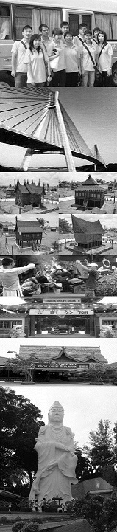
update:181217
Tour Package Include of :
Return Ferry Ticket (Sin/Bth/Sin) by Sindo Ferry Pte Ltd, 1 Night Hotel Accommodation with Breakfast, 1 Day Batam City & Shopping Tour with Seafood Lunch & Land Transfer and Local Guide Assist.
Free & Easy Package Include of :
Return Ferry Ticket (Sin/Bth/Sin) by Sindo Ferry Pte Ltd, 1 Night Hotel Accommodation with Breakfast, Land Transfer (pier/hotel/pier) and Local Guide Assist.
Extension Night Include of :
1 Night Hotel Accommodation with Breakfast.
GV2 | ADULT |  | CHILD
SUPERIOR ROOM | Single | Twin/Trp | Half Twin | With Bed | No Bed | Infant
2D/1N Tour Package | S$111 | S$68 | S$64 | S$64 | S$39 | S$15
2D/1N Free & Easy | S$101 | S$58 | S$56 | S$56 | S$35 | S$15
Extension Night | S$84 | S$42 | S$42 | S$42 | S$11 | FOC
Per person per night

GOLDEN VIEW HOTEL

The Package Exclude of:
- Singapore PDF & Fuel Surcharge of S$21/pax (subject to change)
- Batam Terminal Fee of S$8/pax (subject to change)
- Batam Guide & Driver Tipping of S$2/pax/day.
- Personal Insurance, Room Service, Optional Tours, Porterage Fee, Visa Fee, and all expenses of personal nature

Upgrading Room Surcharge:
- Upgrading to Deluxe Room top-up S$25/r/n, 2BR Family Room S$110/unit/n and Suite S$120/r/n

Eve, PH & School Holiday Surcharge:
- No Public Holiday & Peak Season Surcharge apply.

Fixed Departure:
All above package is based on FIXED DEPARTURE BASIC as following:
- By Tour Package is 0900 hrs.
- By Free & Easy is 0900, 1020, 1320, 1450 & 1720 hrs.
- Pick-up from hotel to Ferry Terminal is all fixed at 1200 hrs.
- Require for early or late departure will be imposed additional surcharge for land transfer is S$10/pax/trip for 8am to 6pm and S$15/pax/trip for 6pm to 9pm and midnight charge for after 9pm is S$25/pax/trip (min must 02 paxs)

Remark:
- Validity from 1 APRIL till 30 DECEMBER 2018.
- Hotel room’s definition for Weekday is Sunday to Thursday and Weekend is Friday to Saturday and eve of & PH.
- No cancellation & no amendment is allowed after reservation made. 100% full fare charge applies.
- Itinerary is subject to change without prior notice
- All prices herein are subject to change without prior notice, arising from currency fluctuation, local taxes, etc.
All prices herein quoted are subject to based on City and Shopping Tour Itinerary (GV2), upgrading to Historical and Shopping Tour (GV6) or Muslim Tour (GV4) TOP-UP S$10/pax

