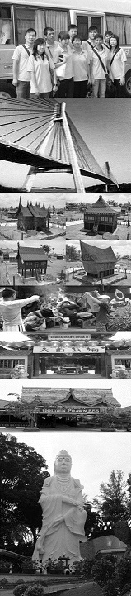
update: 221217
Tour Package Include of :
Return Ferry Ticket (Sin/Bth/Sin) by Sindo Ferry Pte Ltd, 1 Night Hotel Accommodation with Breakfast, 1 Day Batam City & Shopping Tour with Seafood Lunch & Land Transfer and Local Guide Assist.
Free & Easy Package Include of :
Return Ferry Ticket (Sin/Bth/Sin) by Sindo Ferry Pte Ltd, 1 Night Hotel Accommodation with Breakfast, Land Transfer (pier/hotel/pier) and Local Guide Assist.
Extension Night Include of :
1 Night Hotel Accommodation with Breakfast.
GV2 | ADULT |  | CHILD
DELUXE ROOM | Single | Twin/Trp | Half Twin | With Bed | No Bed | Infant
2D/1N Tour Package | S$119 | S$72 | S$68 | S$68 | S$39 | S$15
2D/1N Free & Easy | S$109 | S$62 | S$60 | S$60 | S$35 | S$15
Extension Night | S$92 | S$46 | S$46 | S$46 | S$11 | FOC
Per person per night

ASTON HOTEL BATAM

The Package Exclude of:
- Singapore PDF & Fuel Surcharge of S$21/pax (subject to change)
- Batam Terminal Fee of S$8/pax (subject to change)
- Batam Guide & Driver Tipping of S$2/pax/day.
- Personal Insurance, Room Service, Optional Tours, Porterage Fee, Visa Fee, and all expenses of personal nature

Upgrading Room Surcharge:
- Upgrading to Family Room top-up S$35/r/n & Suite Room top-up S$65/r/n.

Eve, PH & School Holiday Surcharge:
- Subject on Eve & PH Surcharge Surcharge of S$40/r/n will be apply on 12 – 20 June, 22 – 26 Dec, 29 Dec 2018 – 2 January 2019.

Fixed Departure:
All above package is based on FIXED DEPARTURE BASIC as following:
- By Tour Package is 0900 hrs.
- By Free & Easy is 0900, 1020, 1320, 1450 & 1720 hrs.
- Pick-up from hotel to Ferry Terminal is all fixed at 1200 hrs.
- Require for early or late departure will be imposed additional surcharge for land transfer is S$10/pax/trip for 8am to 6pm and S$15/pax/trip for 6pm to 9pm and midnight charge for after 9pm is S$25/pax/trip (min must 02 paxs)

Remark:
- Validity from 1 APRIL till 30 DECEMBER 2018.
- Hotel room’s definition for Weekday is Sunday to Thursday and Weekend is Friday to Saturday and eve of & PH.
- No cancellation & no amendment is allowed after reservation made. 100% full fare charge applies.
- Itinerary is subject to change without prior notice
- All prices herein are subject to change without prior notice, arising from currency fluctuation, local taxes, etc.
- All prices herein quoted are subject to based on City and Shopping Tour Itinerary (GV2), upgrading to Historical and Shopping Tour (GV6) or Muslim Tour (GV4) TOP-UP S$10/pax

