NCERT Solutions for Class 9th: Ch 10 Gravitation Science
n Text Questions
Page No: 134
1. State the universal law of gravitation
Answer
The universal law of gravitation states that every object in the universe attracts every other object with a force called the gravitational force. The force acting between two objects is directly proportional to the product of their masses and inversely proportional to the square of the distance between their centers.
For two objects of masses m₁and m₂ and the distance between them r, the force (F) of attraction acting between them is given by the universal law of gravitation as:
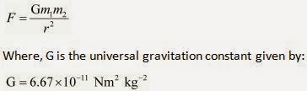
2. Write the formula to find the magnitude of the gravitational force between the earth and an object on the surface of the earth.

Answer

Let M_{E} be the mass of the Earth and mbe the mass of an object on its surface. If R is the radius of the Earth, then according to the universal law of gravitation, the gravitational force (F) acting between the Earth and the object is given by the relation:
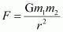
Page No: 136
1. What do you mean by free fall?
Answer
Gravity of earth attracts every object towards its center. When an object is dropped from a certain height , it begins to fall towards Earth’s surface under the influence of gravitational force. Such a motion of object is called free fall.
2. What do you mean by acceleration due to gravity?
Answer
When an object falls freely towards the surface of earth from a certain height, then its velocity changes. This change in velocity produces acceleration in the object which is known as acceleration due to gravity denoted bu letter g . The value of acceleration due to gravity is g= 9.8 m/s².
Page No: 138
1. What are the differences between the mass of an object and its weight?
Answer
Mass | Weight
Mass is the quantity of matter contained in the body. | Weight is the force of gravity acting on the body.
It is the measure of inertia of the body. | It is the measure of gravity.
Mass is a constant quantity. | Weight is not a constant quantity. It is different at different places.
It only has magnitude. | It has magnitude as well as direction.
Its SI unit is kilogram (kg). | Its SI unit is the same as the SI unit of force, i.e., Newton (N).
2. Why is the weight of an object on the moon 1/6th its weight on the earth?
Answer
The mass of moon is 1/100 times and its radius 1/4 times that of earth. As a result, the gravitional attraction on the moon is about one sixth when compared to earth. Hence, the the weight of an object on the moon 1/6th its weight on the earth.
Page No: 141
1. Why is it difficult to hold a school bag having a strap made of a thin and strong string?
Answer
It is difficult to hold a school bag having a thin strap because the pressure on the shoulders is quite large. This is because the pressure is inversely proportional to the surface area on which the force acts. The smaller is the surface area; the larger will be the pressure on the surface. In the case of a thin strap, the contact surface area is very small. Hence, the pressure exerted on the shoulder is very large.

2. What do you mean by buoyancy?
Answer
The upward force exerted by a liquid on an object that is immersed in it is known as buoyancy.
3. Why does an object float or sink when placed on the surface of water?
Answer
→ An object sink in water if its density is greater than that of water.
→ An object floats in water if its density is less than that of water.
Page No: 142
1. You find your mass to be 42 kg on a weighing machine. Is your mass more or less than 42 kg?
Answer
When we weigh our body, an upward force acts on it. This upward force is the buoyant force. As a result, the body gets pushed slightly upwards, causing the weighing machine to show a reading less than the actual value.
2. You have a bag of cotton and an iron bar, each indicating a mass of 100 kg when measured on a weighing machine. In reality, one is heavier than other. Can you say which one is heavier and why?
Answer
The cotton bag is heavier than the iron bar. The cotton bag experiences larger up thrust of air than the iron bar. So, the weighing machine indicates a smaller mass for cotton bag than its actual mass.
Page No: 143
Excercises
1. How does the force of gravitation between two objects change when the distance between them is reduced to half?
Answer
According to Universal Law of gravitation , the gravitational force of attrection between any two objects of mass
M and m is proportional to the product of their masses
and inversly proportional to the square of distance r between them
So, force F is given by
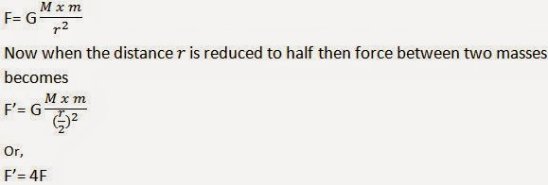
Hence, if the distance is reduced to half, then the gravitational force becomes four times larger than the previous value.
2. Gravitational force acts on all objects in proportion to their masses. Why then, a heavy object does not fall faster than a light object?
Answer
All objects fall on ground with constant acceleration, called acceleration due to gravity (in the absence of air resistances). It is constant and does not depend upon the mass of an object. Hence, heavy objects do not fall faster than light objects.
3. What is the magnitude of the gravitational force between the earth and a 1 kg object on its surface? (Mass of the earth is 6 × 10²⁴ kg and radius of the earth is 6.4 × 10⁶ m).
Answer
Given that,
Mass of the body, m= 1 kg
Mass of the Earth, M= 6 x 1024 kg
Radius of the earth, R= 6.4 x 106 m
Now magnitude of the gravitational force (F) between the earth and the body can be given as,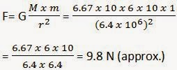
4. The earth and the moon are attracted to each other by gravitational force. Does the earth attract the moon with a force that is greater or smaller or the same as the force with which the moon attracts the earth? Why?
Answer
According to the universal law of gravitation, two objects attract each other with equal force, but in opposite directions. The Earth attracts the moon with an equal force with which the moon attracts the earth.

5. If the moon attracts the earth, why does the earth not move towards the moon?
Answer
The Earth and the moon experience equal gravitational forces from each other. However, the mass of the Earth is much larger than the mass of the moon. Hence, it accelerates at a rate lesser than the acceleration rate of the moon towards the Earth. For this reason, the Earth does not move towards the moon.
Page No: 144
6. What happens to the force between two objects, if
(i) the mass of one object is doubled?
(ii) the distance between the objects is doubled and tripled?
(iii) the masses of both objects are doubled?
Answer
From Universal law of , force exerted on an object of mass m by earth is given by
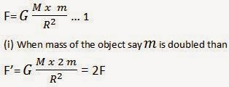
So as the mass of any one of the object is doubled the force is also doubled
(ii) The force F is inversely proportional to the distance between the objects. So if the distance between two objects is doubled then the gravitational force of attraction between them is reduced to one fourth of its original value. Similarly f the distance between two objects is tripled , then the gravitational force of attraction becomes one ninth of its original value.
(iii) Again fron Universal law of attraction from equation 1 force F is directly proportional to the product of both the masses. So if both the masses are doubled then the gravitational force of attraction becomes four times the original value.
7. What is the importance of universal law of gravitation?
Answer
Universal law of Gravitation is important because it it tells us about:
→ the force that is responsible for binding us to Earth.
→ the motion of moon around the earth
→ the motion of planets around the sun
→ the tides formed by rising and falling of water level in the ocean are due to the gravitational force exerted by both sun and moon on the earth.
8. What is the acceleration of free fall?
Answer
Acceleration of free fall is the acceleration produced when a body falls under the influence of the force of gravitation of the earth alone. It is denoted by g and its value on the surface of the earth is 9.8 ms⁻².
9. What do we call the gravitational force between the Earth and an object?
Answer
Gravitational force between the earth and an object is known as the weight of the object.
10. Amit buys few grams of gold at the poles as per the instruction of one of his friends. He hands over the same when he meets him at the equator. Will the friend agree with the weight of gold bought? If not, why? [Hint: The value of gis greater at the poles than at the equator].
Answer
Weight of a body on the Earth is given by:
W= mg
Where,
m= Mass of the body
g= Acceleration due to gravity
The value of gis greater at poles than at the equator. Therefore, gold at the equator weighs less than at the poles. Hence, Amit's friend will not agree with the weight of the gold bought.
11. Why will a sheet of paper fall slower than one that is crumpled into a ball?
Answer
When a sheet of paper is crumbled into a ball, then its density increases. Hence, resistance to its motion through the air decreases and it falls faster than the sheet of paper.
12. Gravitational force on the surface of the moon is only 1/6 as strong as gravitational force on the Earth. What is the weight in newtons of a 10 kg object on the moon and on the Earth?
Answer
Weight of an object on the moon = 1/6 x Weight of an object on the Earth
Also,
Weight = Mass x Acceleration
Acceleration due to gravity, g = 9.8 m/s2
Therefore, weight of a 10 kg object on the Earth = 10 x 9.8 = 98 N
And, weight of the same object on the moon= 1.6 x 9.8 = 16.3 N.
13. A ball is thrown vertically upwards with a velocity of 49 m/s. Calculate
(i) the maximum height to which it rises.
(ii) the total time it takes to return to the surface of the earth.

Answer

According to the equation of motion under gravity:
v² - u²= 2 gs
Where,
u= Initial velocity of the ball
v= Final velocity of the ball
s= Height achieved by the ball
g= Acceleration due to gravity
At maximum height, final velocity of the ball is zero, i.e., v= 0
u= 49 m/s
During upward motion, g= - 9.8 m s⁻²
Let h be the maximum height attained by the ball.
Hence,
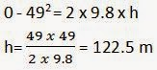
Let t be the time taken by the ball to reach the height 122.5 m, then according to the equation of motion:
v= u + gt
We get,
0= 49 + t x (- 9.8)
9.8t= 49
t= 49 / 9.8= 5s
But,
Time of ascent = Time of descent
Therefore, total time taken by the ball to return = 5 + 5 = 10 s
14. A stone is released from the top of a tower of height 19.6 m. Calculate its final velocity just before touching the ground.
Answer
According to the equation of motion under gravity:
v² − u² = 2 gs
Where,
u = Initial velocity of the stone = 0
v = Final velocity of the stone
s = Height of the stone = 19.6 m
g = Acceleration due to gravity = 9.8 m s⁻²
∴ v² − 0² = 2 × 9.8 × 19.6
v² = 2 × 9.8 × 19.6 = (19.6)²
v = 19.6 m s⁻ ¹
Hence, the velocity of the stone just before touching the ground is 19.6 m s⁻¹.
15. A stone is thrown vertically upward with an initial velocity of 40 m/s. Taking g = 10 m/s², find the maximum height reached by the stone. What is the net displacement and the total distance covered by the stone?
Answer
According to the equation of motion under gravity:
v² − u² = 2 gs
Where,
u = Initial velocity of the stone = 40 m/s
v = Final velocity of the stone = 0
s = Height of the stone
g = Acceleration due to gravity = −10 m s⁻²
Let h be the maximum height attained by the stone.
Therefore,
0 - (40)2 = 2 x h x (-10)
h= 40 x 40 / 20 = 80 m
Therefore, total distance covered by the stone during its upward and downward journey = 80 + 80 = 160 m
Net displacement of the stone during its upward and downward journey
= 80 + (−80) = 0
16. Calculate the force of gravitation between the earth and the Sun, given that the mass of the earth = 6 × 10²⁴ kg and of the Sun = 2 × 10³⁰ kg. The average distance between the two is 1.5 × 10¹¹m.
Answer
According to question,
M_{Sun} = Mass of the Sun = 2 × 10³⁰ kg
M_{Earth} = Mass of the Earth = 6 × 10²⁴ kg
R = Average distance between the Earth and the Sun = 1.5 × 10¹¹m
From Universal law of gravitation,
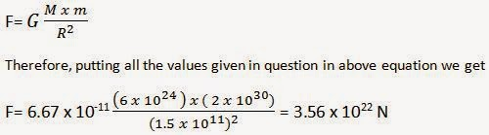
17. A stone is allowed to fall from the top of a tower 100 m high and at the same time another stone is projected vertically upwards from the ground with a velocity of 25 m/s. Calculate when and where the two stones will meet.
Answer
Let t be the point at which two stones meet and let h be their height from the ground. It is given in the question that height of the tower is H= 100m

Now first consider the stone which falls from the top of the tower. So distance covered by this stone at time t can be calculated using equation of motion
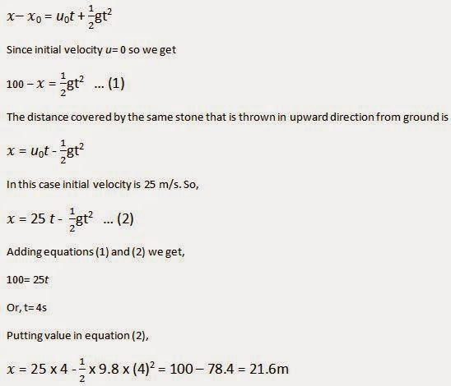

18. A ball thrown up vertically returns to the thrower after 6 s. Find
(a) the velocity with which it was thrown up,
(b) the maximum height it reaches, and
(c) its position after 4 s.
Answer
(a) Time of ascent is equal to the time of descent. The ball takes a total of 6 s for its upward and downward journey.
Hence, it has taken 3 s to attain the maximum height.
Final velocity of the ball at the maximum height, v = 0
Acceleration due to gravity, g = −9.8 m s⁻²
Equation of motion, v = u + gt will give,
0 = u + (−9.8 × 3)
u = 9.8 × 3 = 29.4 ms⁻ ¹
Hence, the ball was thrown upwards with a velocity of 29.4 m s⁻¹.
(b) Let the maximum height attained by the ball be h.
Initial velocity during the upward journey, u = 29.4 m s⁻¹
Final velocity, v = 0
Acceleration due to gravity, g = −9.8 m s⁻²
From the equation of motion, s= ut + 1/2 at²
h= 29.4 x 3 + 1/2 x -9.8 x (3)² = 44.1 m
(c) Ball attains the maximum height after 3 s. After attaining this height, it will start falling downwards.
In this case,
Initial velocity, u = 0
Position of the ball after 4 s of the throw is given by the distance travelled by it during its downward journey in 4 s − 3 s = 1 s.
Equation of motion, s= ut + 1/2 gt² will give,
s= 0 x t + 1/2 x 9.8 x 1² = 4.9 m
Total height = 44.1 m
This means that the ball is 39.2 m (44.1 m − 4.9 m) above the ground after 4 seconds.
Page No: 145
19. In what direction does the buoyant force on an object immersed in a liquid act?
Answer
An object immersed in a liquid experiences buoyant force in the upward direction.
20. Why does a block of plastic released under water come up to the surface of water?
Answer
For an object immersed in water two force acts on it
→ gravitational force which tends to pull object in downward direction
→ buoyant force that pushes the object in upward direction
here in this case buoyant force is greater than the gravitational pull on the plastic block. This is the reason the plastic block comes up to the surface of the water as soon as it is released under water.
21. The volume of 50 g of a substance is 20 cm³. If the density of water is 1 g cm⁻³, will the substance float or sink?
Answer
If the density of an object is more than the density of a liquid, then it sinks in the liquid. On the other hand, if the density of an object is less than the density of a liquid, then it floats on the surface of the liquid.
Here, density of the substance = Mass of the substance / Volume of the substance
= 50 / 20
= 2.5 g cm⁻³
The density of the substance is more than the density of water (1 g cm⁻³). Hence, the substance will sink in water.
22. The volume of a 500 g sealed packet is 350 cm³. Will the packet float or sink in water if the density of water is 1 g cm⁻³? What will be the mass of the water displaced by this packet?
Answer
Density of the 500 g sealed packet= Mass of the Packet / Volume of the Packet
= 500 / 350
= 1.428 g cm⁻³
The density of the substance is more than the density of water (1 g cm⁻³). Hence, it will sink in water.
The mass of water displaced by the packet is equal to the volume of the packet, i.e., 350 g.

